Complete Order

Document Information

|  |  |
| --- | --- |
| **Document Title** | Title of use case – Verb Noun phrasing is almost always the most appropriate! |
| **Document Owner** |  |
| **Version** |  |
| **Status** |  |
| **Date** |  |

1. Brief Description

This use case describes the process of a food service staff member completing an order for a student at lunchtime.

1. Actors

* Food Service Staff

1. Trigger

The Food Service Staff wants to compete an order.

1. Pre-Conditions

* The Food Service Staff member must be logged into the system.
* The student's order must be confirmed.

1. Post-Conditions

* The order status is updated from “confirmed” to "completed".

1. Basic Flow
2. The student logs in to the system.
3. The student navigates to “My Order” section.
4. The system displays a list of orders made by the student.
5. The student selects the order which they want to receive.
6. The student gives the order code to the Food Service Staff.
7. The Food Service Staff enters the order code into the system.
8. The Food Service Staff selects “Check” button to check the order.
9. The system validates the order code and displays the details of the student's order, including the food items and any special instructions.
10. The Food Service Staff retrieves the food items from the lunch counter and gives them to the student.
11. The Food Service Staff selects “Complete” button to complete the order.
12. The system updates the order’s status to “completed”.
13. Alternate Flows
14. Exception Flows

* 7a: If the order code from an order is not “confirmed”, the system displays an error message and prompts the Food Service Staff to re-enter the order code. The use case then returns to step 6.

1. Business Rules

* The Food Service Staff must retrieve the food items before completing the order.
* The order code must be retrived from an “confirmed” order.

1. Non-Functional Requirements

* The system must be able to update order status in real-time.

1. Supplemental Requirements
2. Visual Model

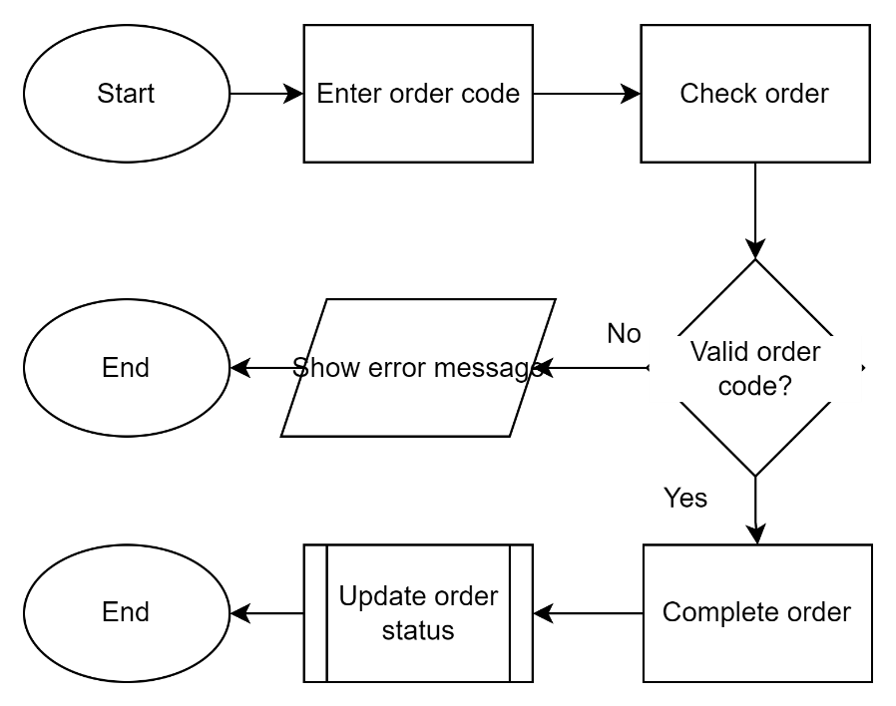

Revision History

|  |  |  |  |  |
| --- | --- | --- | --- | --- |
| V. | Date | Author | Description | Status |
|  |  |  |  |  |
|  |  |  |  |  |